Sasha Evdakov

What is Bull and Bear in Stock Market?
Bull means upward trending, Bear means upward trending.

What is a stock?
A stock is a piece or part of a company.
Companies do it to gain revenue (equity financing).
When I buy stocks, I invest in that company.

3 Types of Stock
1) Common stock. Traded among the general public on stock exchange.
2) Preferred stock. Pay more to get it or work for the company. They get paid first.
3) Unlisted. Not traded on exchanges. Can be traded within the company.

Ticker Symbols
Abbreviation for the company on the stock market.
Unique in time.

Basics of Bidding
Bid: What we want to get the order at.
Ask: What we actually have to pay to get that order.
Spread: Difference between Bid and Ask. The people on the trading floor keep the spread as their payment for executing that order.
Therefore, buying and selling immediately will cause you to lose money.

Long and Short
Long: positive on the stock. We want it to go up
Short: negative on the stock. Want it to go down.

What is an IPO?
Initial Public Offering
First time that stock is released to the public.
Preferred holders dump their shares to the public, causing the stock to go down even if it is a good company.
Wait for the noise to settle down and then look for setups.
Read into the company to see when early investors are allowed to dump their shares.
Usually can’t short IPO’s

Swing and Day Trading
Swing trading has better potential.
Day trading: Holding a stock for less than a day.
Swing trading: Holding a position for multiple days. Up to 5-6 weeks. Trying to capture the overall trend rather than manipulating the volatility. Gap up and down.

What is a stock split?
Example: Day 1: 100 shares at $50/share. Then the stock splits 2/1
Day 2: 200 shares at $25/share. Still own the same amount.
Companies split stocks to add more shares into the market, allowing new money to come in at a lower value.

Diversification
Buy stocks from various industries.
Stocks in the same industries follow each other.
This is very important for long-term investment, but not as much in swing trading if your strategy is good.
Gains not as large.

Fundamental Analysis: Top-Down vs Bottom-Up
Consider the following factors:
1) Health of Economy
2) Industry
3) Earnings
Top down: go from 1 – 3.
Bottom down: go from 3 – 1

Technical Analysis: Channels
Sideways moving
Resistance is the top line, Support is bottom line. Stock oscillates between these
Accelerating channel: Still oscillating, but upward trend.
Enter when it breaks the channel marker! Wait for volume confirmation.
Stocks do this as a “breath of air”

Stock Trading Mistake: Avoid Missed Opportunities
Don’t enter at the pivot, assuming that it will repeat it’s passed oscillation. Wait for it to clear (begin its uptrend) before buying. Past <> Future.
Use patterns as guides and play by the rules.
Wait for the volume confirmation too!

Trading Paper and Learning to Trade
Trading stocks on a simulator.
Important to develop strategies on a simulator.
1) Learn as much as you can
2) Paper trade on a simulator to hone the strategy. Do this until you hit your daily trading goals.
3) Live trading, low shares. Trade ~5 shares, and just confirm that you are right. You’re not really trying to make money, still just getting experience. On the side, imagine that you actually traded 50-100 shares, and see how much you would have made/lost. Do this until you hit your daily trading goals.
4) Live trade with larger share amounts.
2 and 3 are different because stocks are not always available in live trading like they are in paper trading. Human psychology plays a huge role in live trading.

Stock Options: LEAPS
Long Term Equities Anticipated Securities.
Stock options that are over a year long.
LEAP buys more time in your option.

Stocks vs Options
Similar: Tradeable, bid-ask spread, listed on same exchanges.
Differences: Options expire over time, no set number of options (you can create them out of thin air), Stocks own a piece of the company, but options do not.

Stock Trading Mistake: When you are right but still lose
Bad timing.
Example: shorting a stock when it’s still going up, but you had to take a loss because it keeps growing. Then it goes back down, and you punch yourself in the balls.

Technical Analysis: Trend Lines in Stocks
Way to help predict stock price.
You can create arbitrarily many trend lines, but most of them are uselessly weak. The more times a trend line is hit, the stronger it is.
It’s important to see changing trend line over time.
A stock can hit a line twice, go up (or down) and appear to create a new line, and then go back to the original trend line. This validates the original trendline, and now we have a sort of channel.
Trendline spacing should be fairly even.
Steeper trendlines are not as valid as the shallower ones because the stock moves through the price levels so much faster. Support and resistance take time to build, so steeper trend lines usually don’t last long.

Understanding Gaps: Common, Breakaway, Runaway, Exhaustion
Gaps usually happen between day to day.
Typically caused by fundamental changes in the industry or company (like earnings report).
Common gap (both ways): Not usually tradeable. Usually the gap gets filled (the stock price returns to whatever it was doing before the gap)
Breakaway gap (downside): Typically happens when a stock oscillates on its support; people think it’s going to go somewhere, so they start buying into it. After a while, people get sick of it, so there’s a massive sell, which causes the price to gap below it’s support. (Really good short opportunity, make sure you confirm the volume).
Runaway gap (upside). Usually happens with new product launches and news events. More powerful if they come out of a chart pattern.
Exhaustion gap (both ways): Most exciting, but very dangerous and volatile. Trending upward, then supernova, then gaps up. At this point, the support is very week, so it stock will likely trend down. During the supernova, people are freaking out about it, so they pour hella money into it, which causes the gap. Then, everyone starts dumping, which causes the downtrend.

Technical Analysis: Support and Resistance
Support: People think that the demand is strong enough to support the stock price.
Like trend lines, support lines strengthen by the number of times they are hit.
Resistance: same psychology, opposite effect.
If a stock breaks through the resistance, that new resistance becomes support, especially if the resistance was very strong.
Support and resistance can be sloped, and if the slopes are different, then we get a wedge.
If the support or resistance is broken, then the perception of the stock has changed.

Stock Market Charts: Double Top Reversal Pattern
Bearish pattern. Needs an early, prior positive trend in order for it to be a reversal.
After a positive trend, the stock begins to oscillate between a new support and resistance.
Common for it to hit the support twice.
Be careful of the confluence, because the stock can create another double top.
This can be a reversal going up, but double bottoms take longer to happen.
Going short after the double top is dangerous because of confluence, but if the stock truly breaks its support, it will probably oscillate between a new set of support and resistance determined by the Fibonacci numbers.
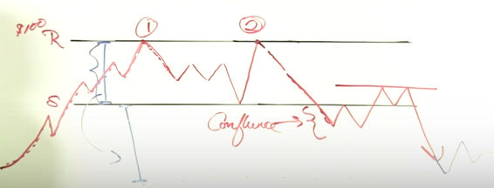

Stock Market Charts: Double Bottom
Bullish reversal picks up from a negative trend.
Bottoms take a much longer to form than tops
Bottoms can have tops within them.
Distance in the tops are much shorter time span.
Enter off the second bottom, confirming with volume. This is risky because it can still oscillate.
Better to enter after it breaks the resistance formed from the double top.

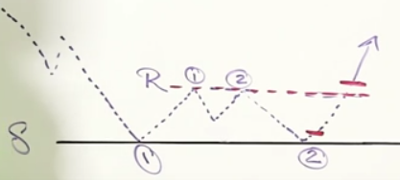

Stock Market Charts: Head and Shoulders Pattern
Reversal bearish pattern: requires a prior uptrend.
Left shoulder volume is greater than the head volume.
After the right shoulder, the support usually becomes the resistance.
Left and right shoulder create a resistance.
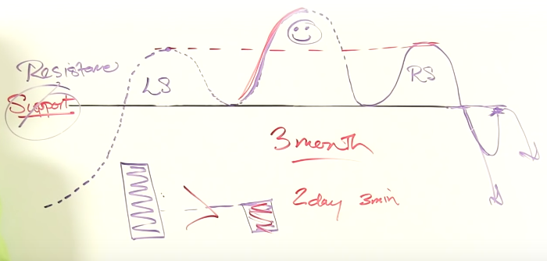
Go short after the right shoulder, but only if there is strong negative volume

Understanding Market Volatility and Trading on Volatile Days
Volatility is the magnitude (range) of the change, excluding trend
Trends are much harder to spot in a volatile market, like trying to find patterns in a choppy ocean.
Swing trading is definitely more risky; better stick to day trading ETFs and inverse ETFs
Long term investment isn’t really effected by this.

Basics of Stock Dividends
Dividends are payments to investors usually every quarter.
Not every stock pays out dividends .
The income from dividends is minuscule compared to the potential from trading

Understanding Calls and Puts
Call is the right to buy a stock. Put is the right to sell a stock (you don’t have to, but you have the right to)
It freezes the stock price. So if you buy a call at $50 and the price goes up, you can still buy the stock at $50 regardless of the price (this increases the option value), but this ability will expire.
You can sell the contract (options), but its worth deteriorates over time.

Understanding VIX – The Fear Index in Stocks
VIX is the fear index (not a stock)
Based on the amount of puts being purchased on the SPX
People usually but puts to protect themselves.
VIX is all relevant. Depends on the values around it in time.
When the VIX is high, it’s time to buy. When the VIX is low, look out below.
Fear causes people to sell, driving down the stock price.
VIX is a great predictor!

Options Basics and Fundamentals
Options are packets of 100 shares
Expire 3rd Friday of the expiration month
Strike Price = Exp Price
Must pay a premium to own the option.

How supports can become resistance and vise-versa

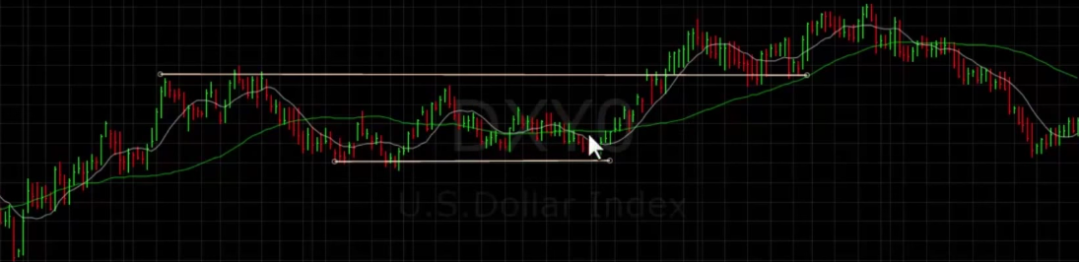
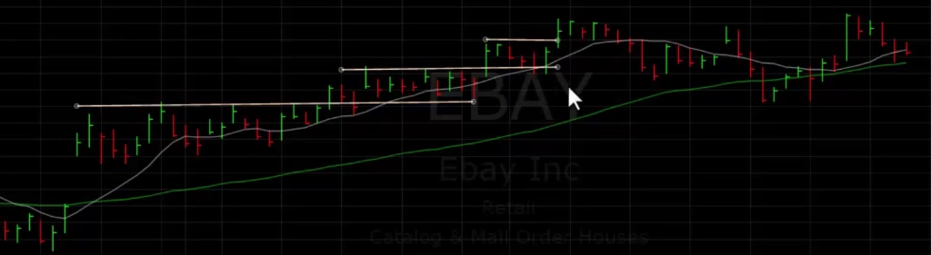
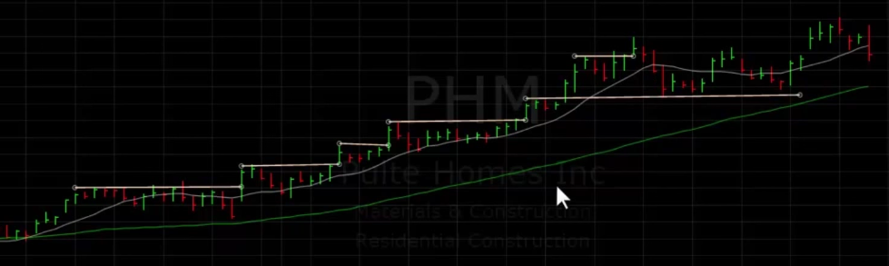

Changing the time View to Spot Trends and Find Chart Patterns on Messy Charts
Low volume stocks (less than 1 million) are more volatile
On the daily, maybe not sure if its a channel or a flag.

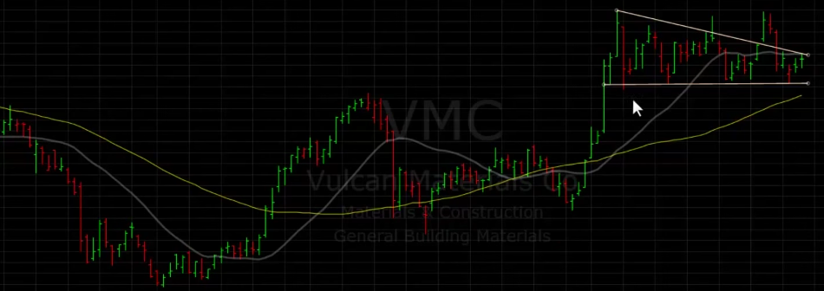
Looking at the weekly confirms that it is more of a flag.
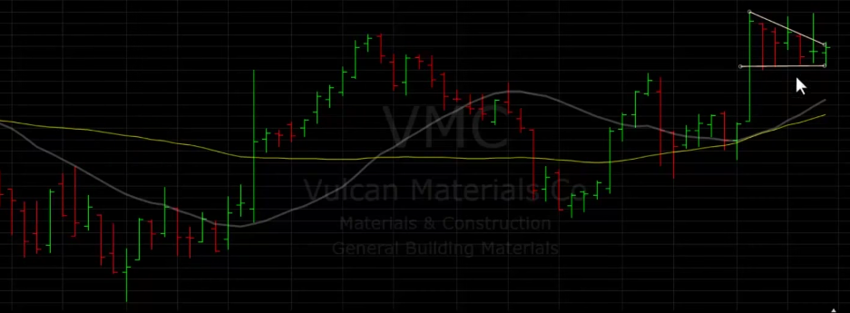
Go back even to monthly to see overall trends and not get lost in the details.
Longer-time support is much stronger

Buying Stocks Bouncing Off Support vs Breaking Resistance
You can buy a stock when it bounces off the support or through the resistance.
Support buying is better for risk management because the resistance may not act as a very strong support when the stock breaks into level 2, so the stock may dip back down to level 1, causing you to lose potential gains from buying at the breakthrough.
Make sure you keep a very tight stop on the support in case the stock beings to fall.

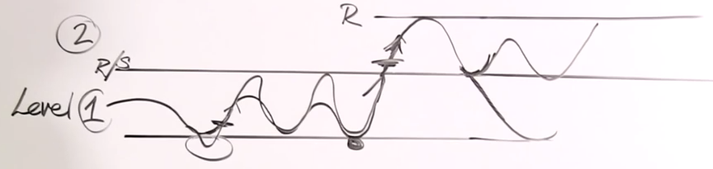
When the dollar goes up, stocks tend to go down.

08/06/2013 Stock Discussion
AAPL: Broke resistance, so go long, but then we see that the volume doesn’t support that position, so we peel back almost everything.

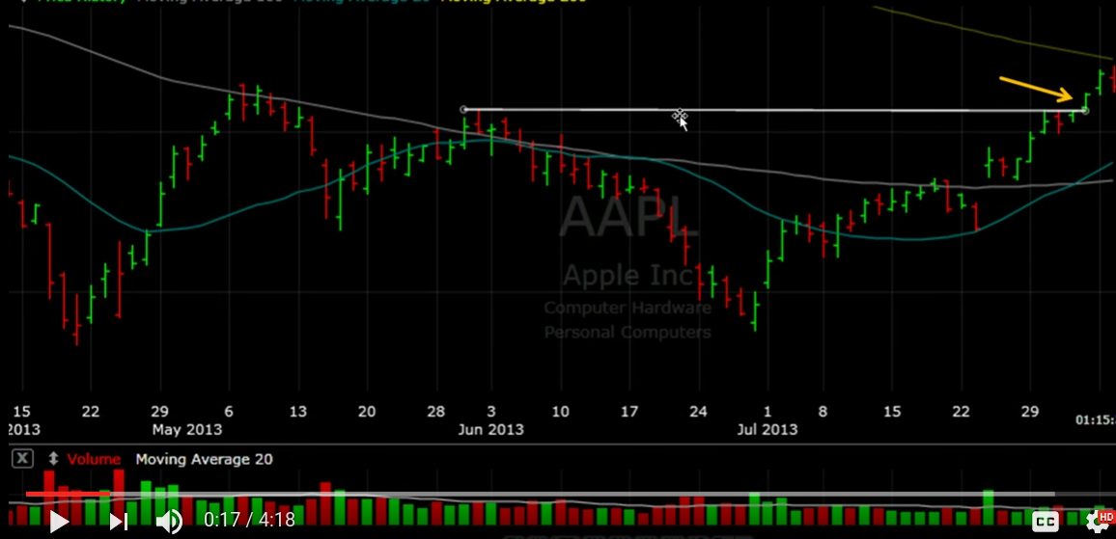

MA: Support is driving the stock into a wedge, indicating a possible breakout. Then a bull flag happens, probably going to be another one or two.

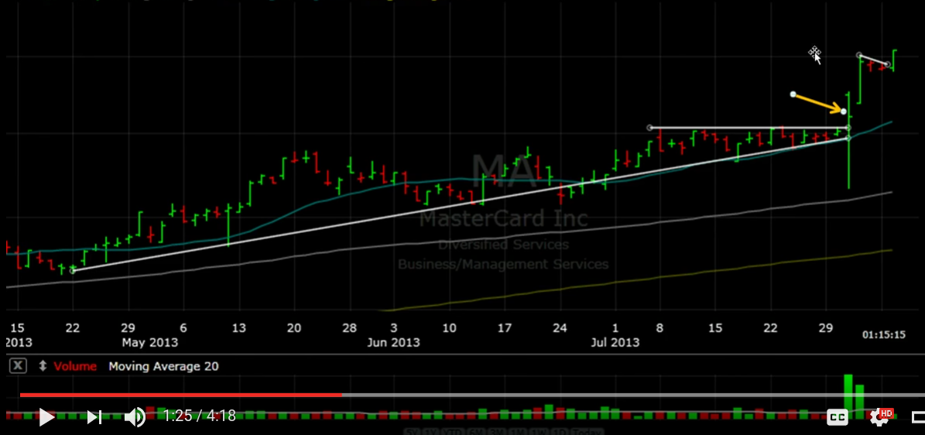
Here’s another one to show how strong that resistance is, so the break is definitely a big deal.
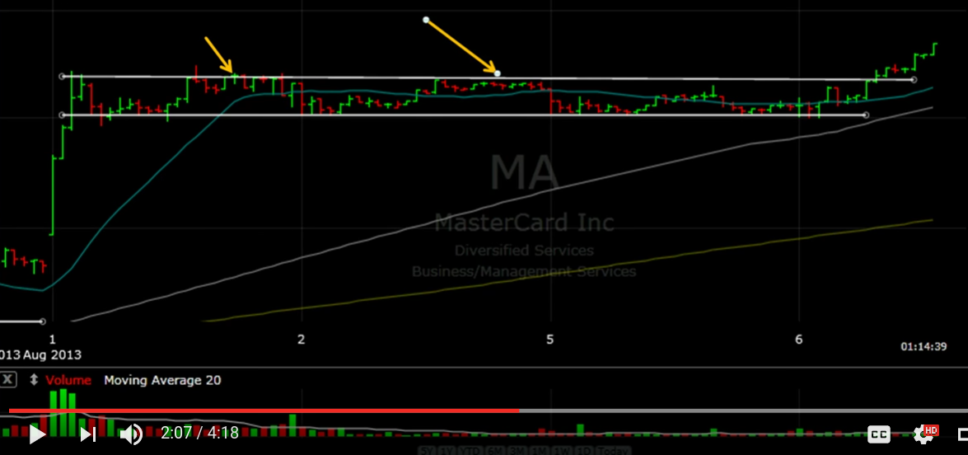

NKE: Notice how the 100 day moving average is wedging the stock.

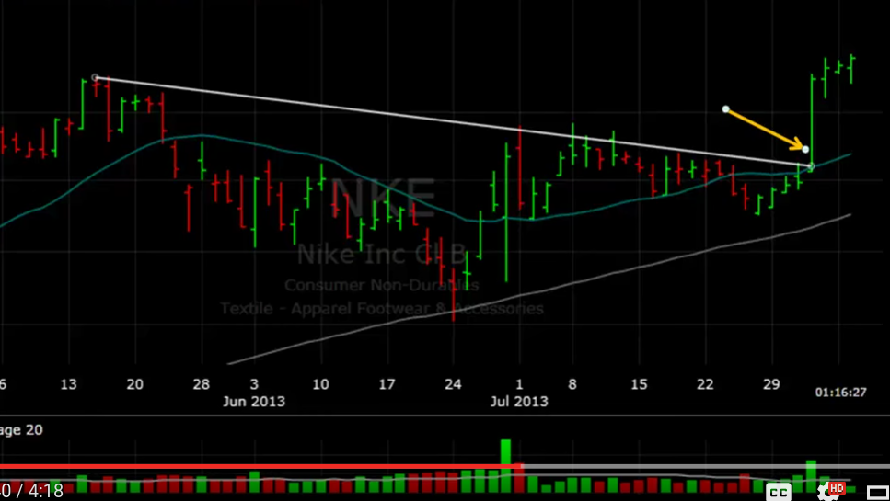
TSN: Broke support for some okay gains.

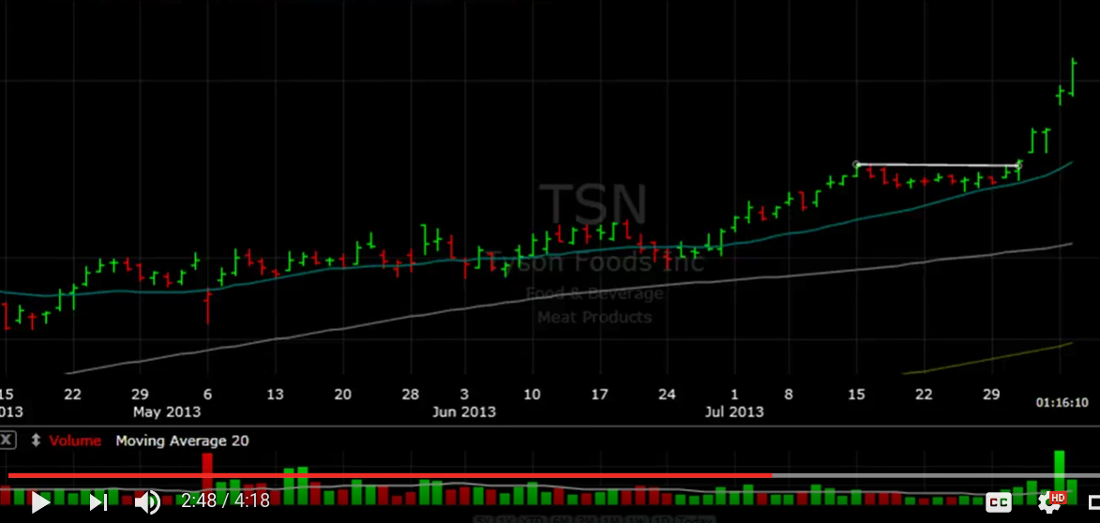

PCLN: Consolidation after an uptrend, then it breaks again.

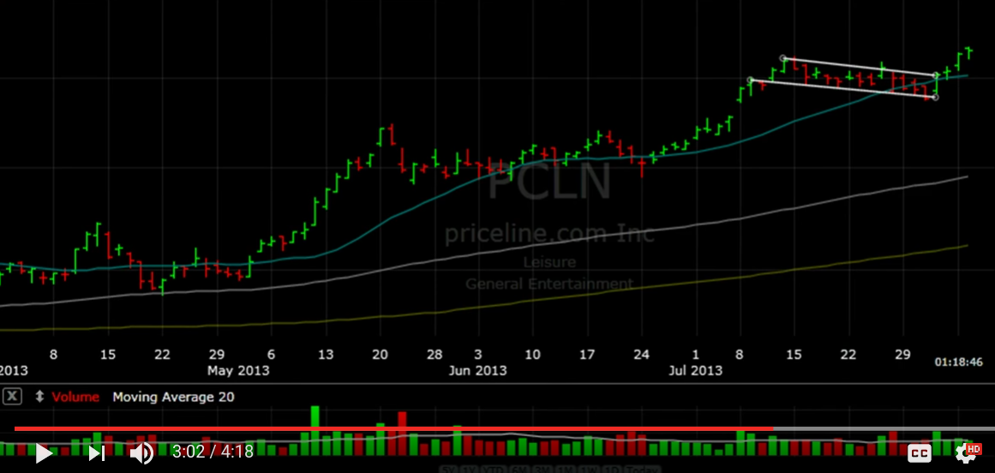
General thoughts: These stock patterns are nice to analyze, but the gains are pretty small for our small accounts. Need a way to find big moving cheap stocks with decently sized volume (maybe 1-10 million, but that might not be volatile enough for us).

Creating Your Own Trading Strategy
Third circle looks like it might break, but it’s just confluence because there is no volume to take it higher.

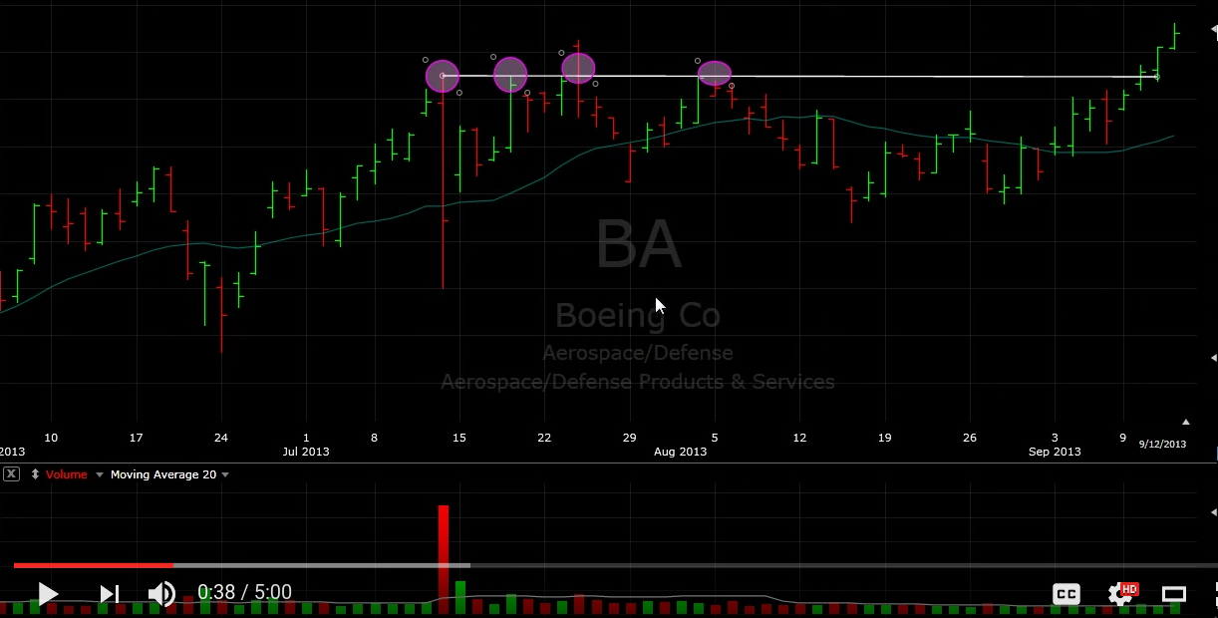

Support wedges the stock to the previous resistance, and then it breaks
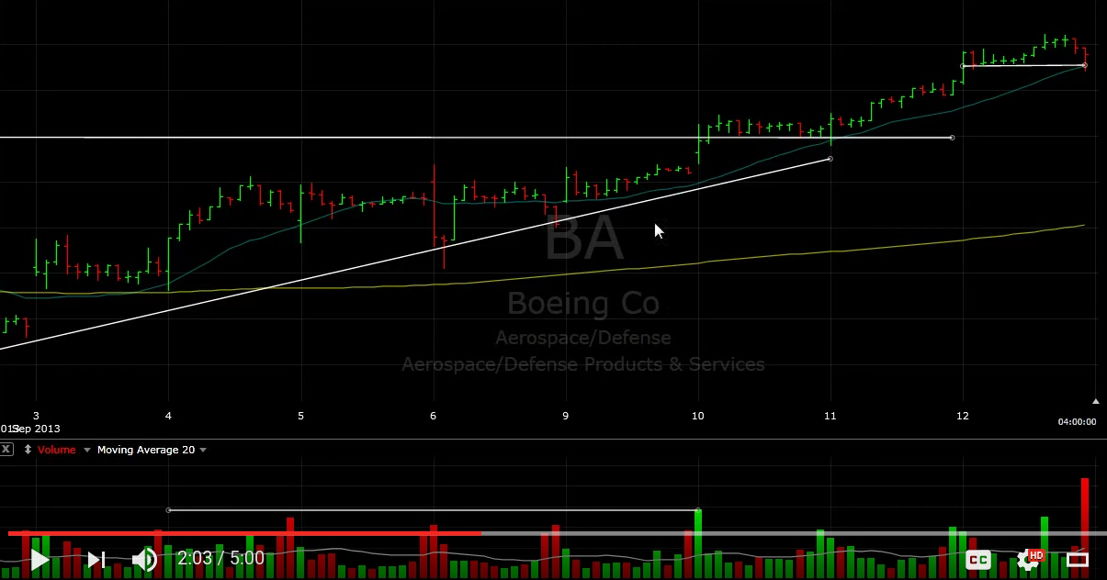
Now we start to see a stair step pattern.
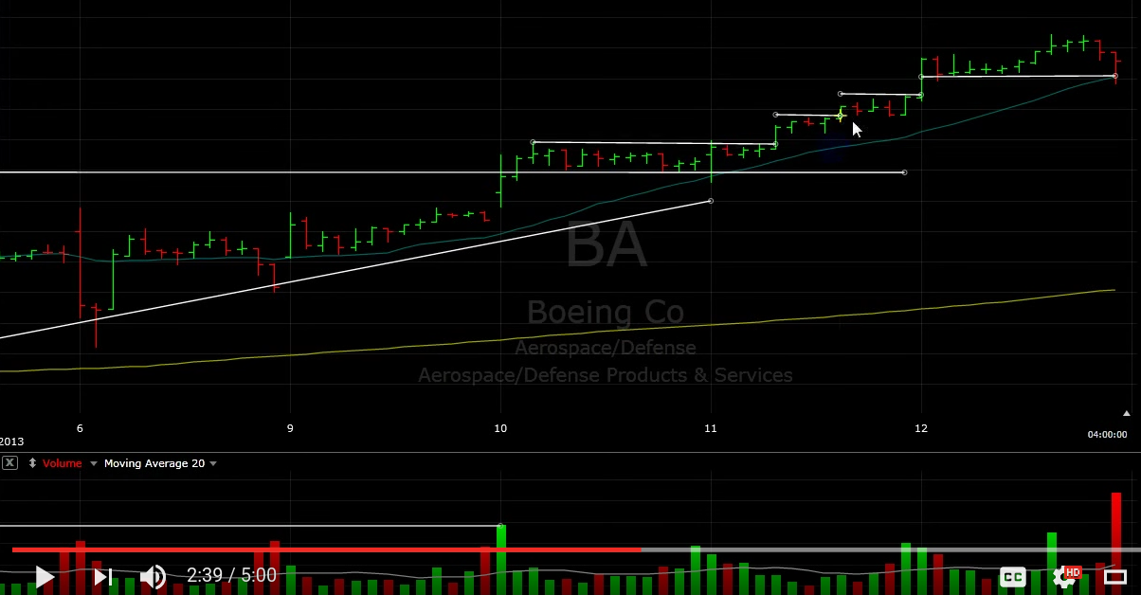
But again, even this stock is barely moving. Only a few points over days.

Stock Chart Pattern: Ascending Triangle
This is where the support wedges the stock into the resistance.
Volume doesn’t always confirm breakout.

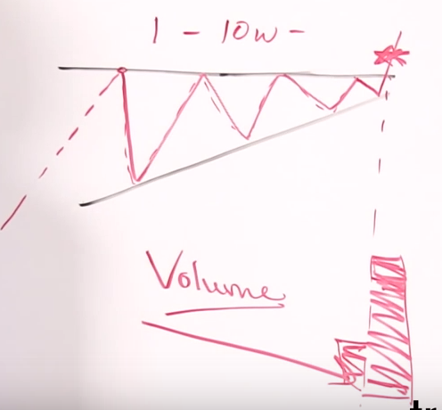

Stock Chart Pattens: Cup and Handle
Needs to come off a trend.
When it breaks the handle, the volume needs to be high because it has to break through strongly.
Emphasize the U-shape

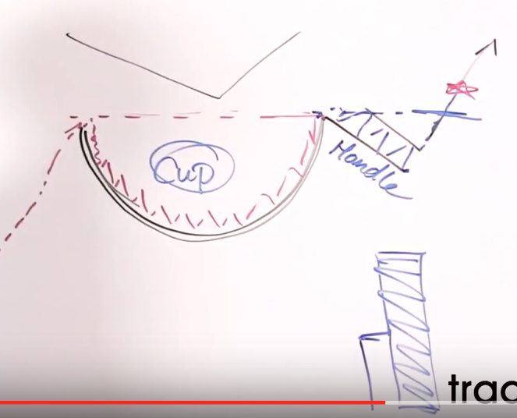

Stock Chart Pattern: Triple Bottom (and Top)
Reversal Pattern comes off a downtrend.
Neutral pattern until it hits the third bottom (can become lots of things)
If it breaks after the third hit, then it will likely break to an upward trend.
Works the same way with triple top.

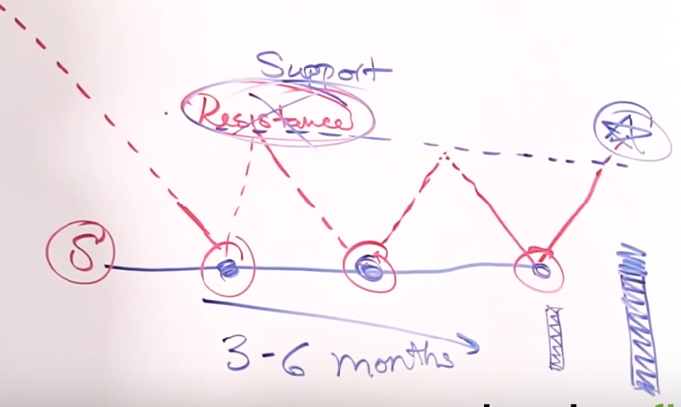

Understanding Stock Sympathy Plays
Example: Google invents something awesome which effects many companies in that sector. If we miss the uptrend from GOOG, we may still get it later in YAHOO.
On the other hand, it would hurt newspaper and print companies.

Overhead Supply within Stocks
Area of resistance with more supply then we believe.
Created when a stock dips down quickly and many people still holding on to that stock. When the price rises up again, the overhead supply level creates a resistance.

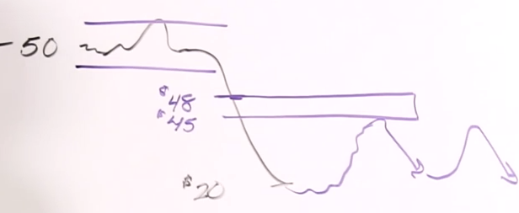

Starting Account Balance
If your account is less than $25,000 you cannot do more than 3 day trades every 5 days

